22 faculty members shown
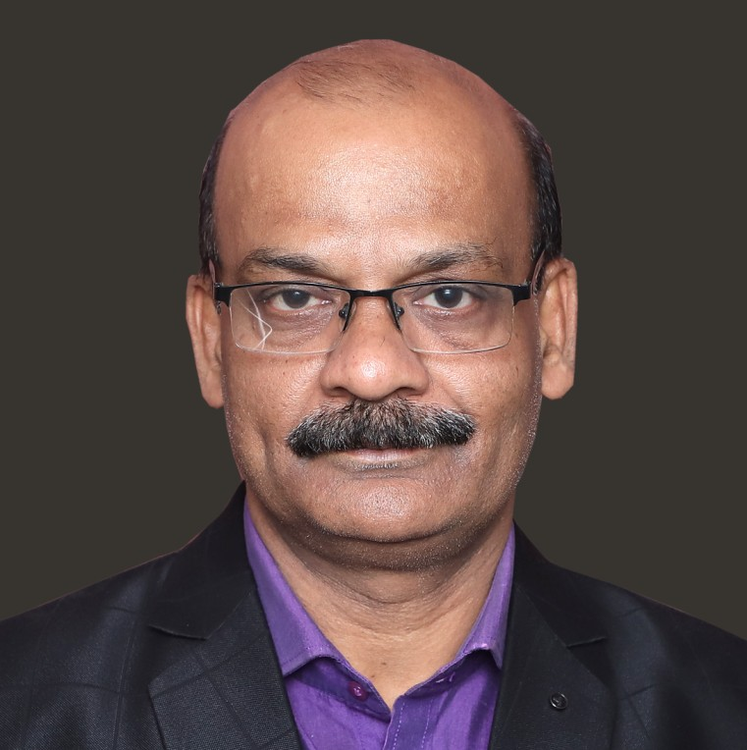
Dr. Umakanta Dash
Principal & Professor
drukdash@srustiacademy.ac.in
View Profile
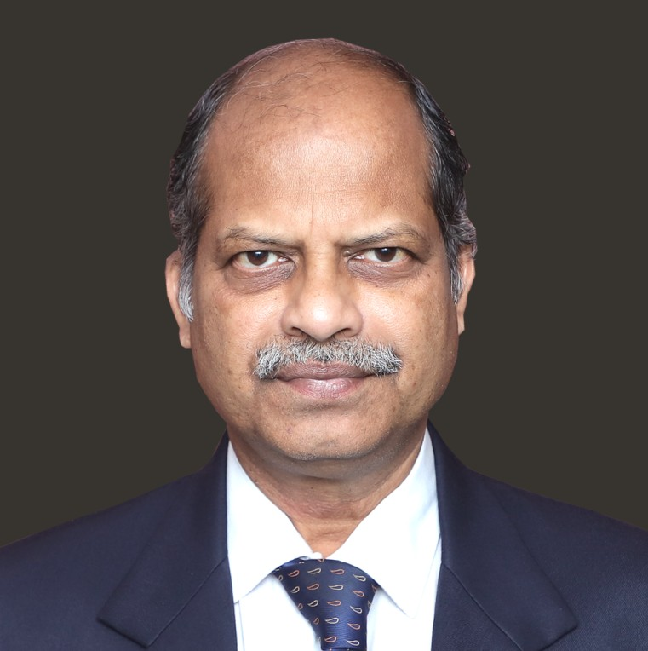
Dr. Gangadhar Mishra
Dean (Training and Placement) & Professor
placement@srustiacademy.ac.in
View Profile
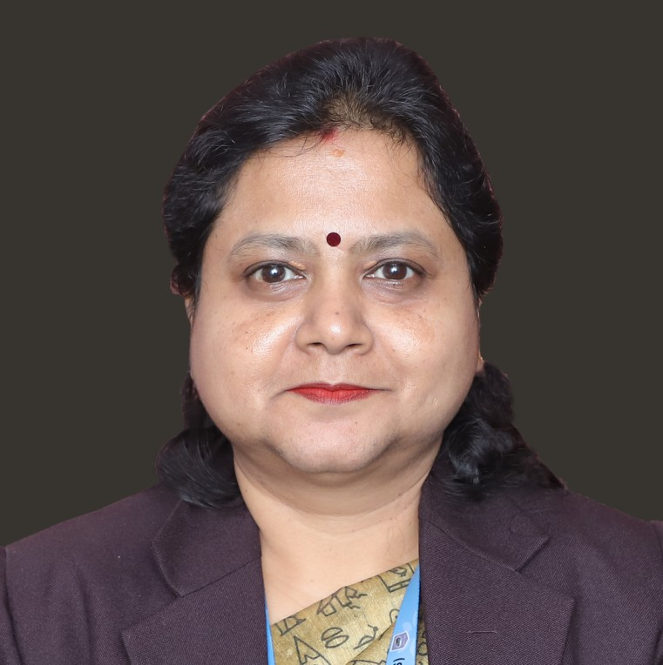
Dr. Pragyan Parimita Sarangi
Vice- Principal and Associate Professor
drpragyan@srustiacademy.ac.in
View Profile
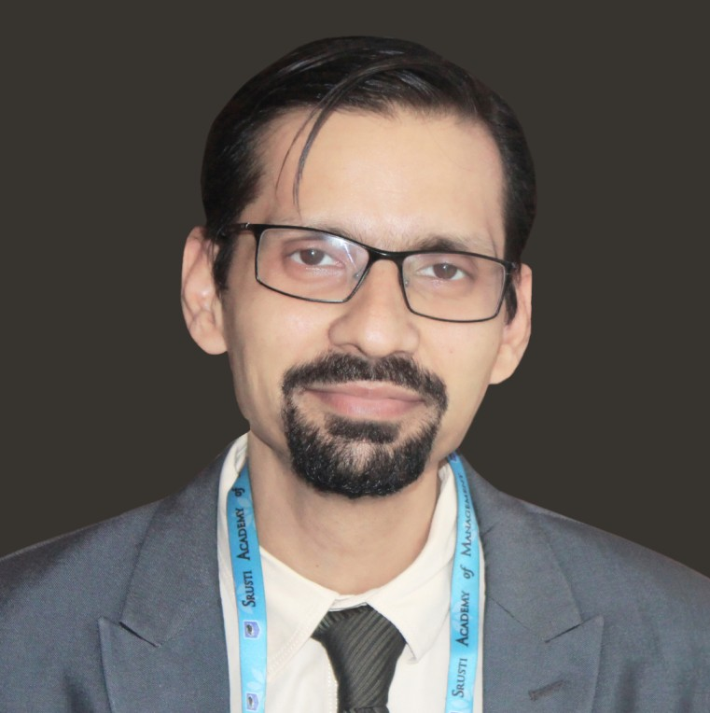
Dr. Arpan Mahapatra
Associate Professor
drarpan@srustiacademy.ac.in
View Profile
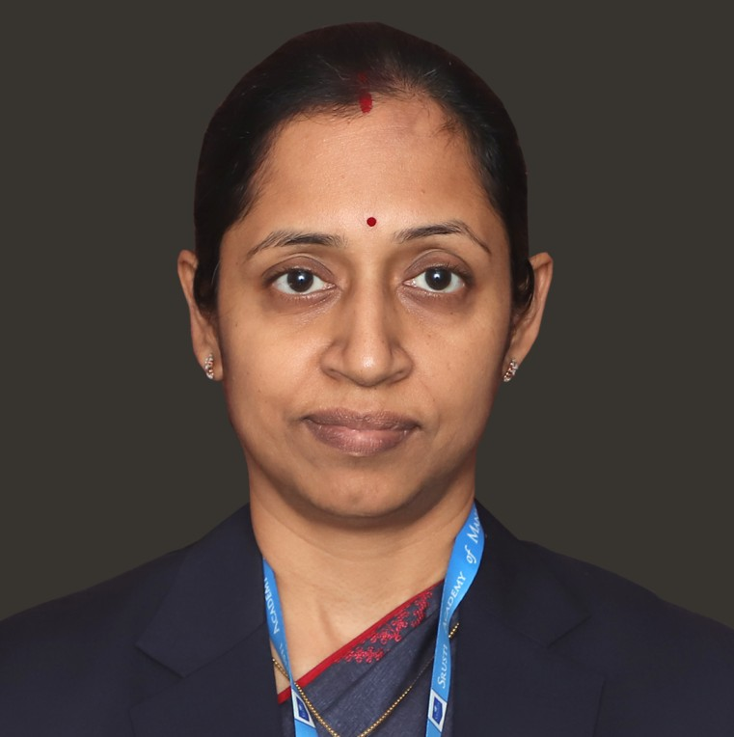
Dr. Anuradha Mishra
Associate Professor
dranuradha@srustiacademy.ac.in
View Profile
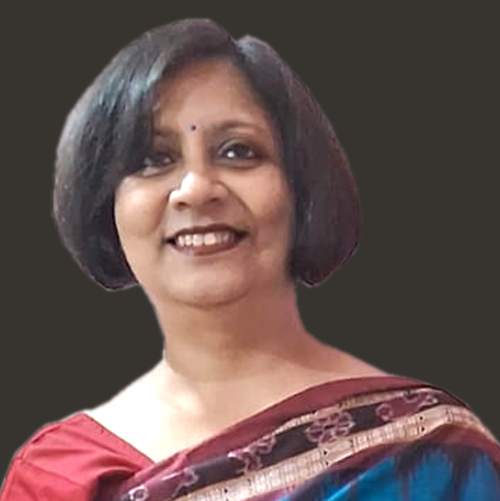
Dr. Susmita Parija
Trainning Head, Associate Professor
drsusmita@srustiacademy.ac.in
View Profile
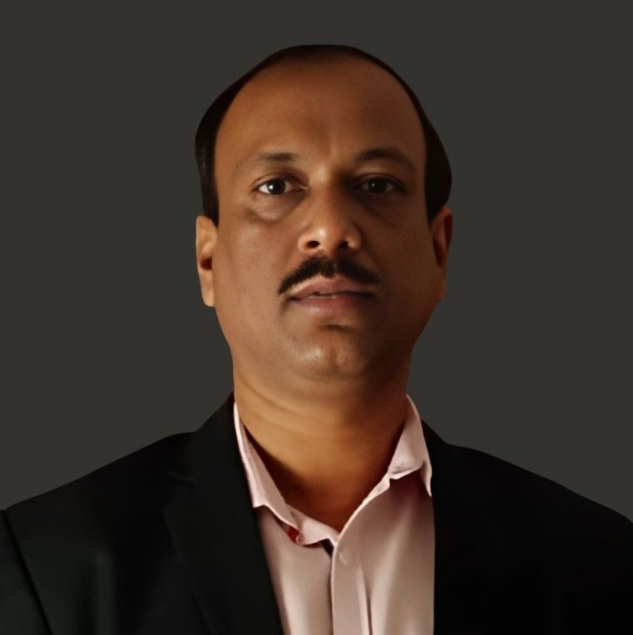
Dr. Jakki Samir Khan
Associate Professor
drjakki@srustiacademy.ac.in
View Profile
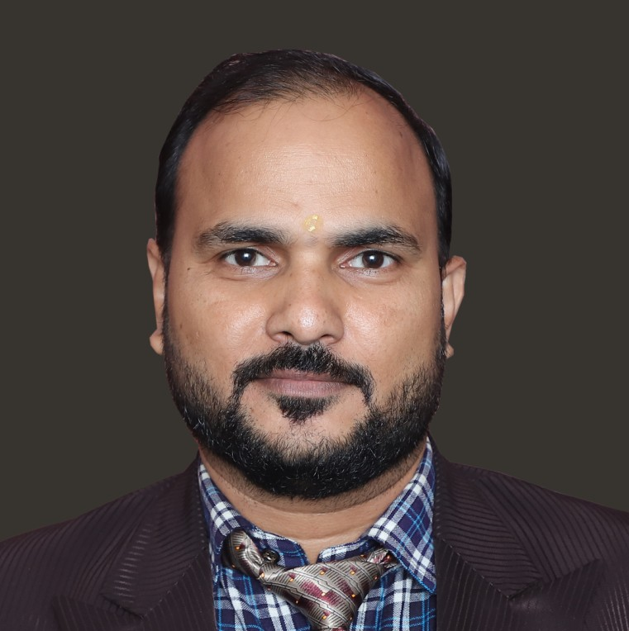
Mr. Nirmal Kumar Routra
Controller of Exam & Assistant Professor
nirmal@srustiacademy.ac.in
View Profile
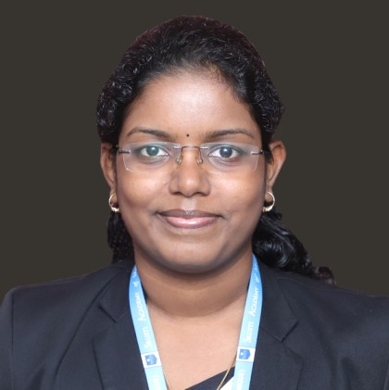
Ms. Kalyani Senapati
Assistant Professor
kalyani@srustiacademy.ac.in
View Profile
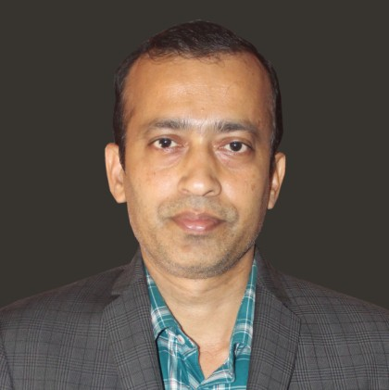
Mr. Dharma Ku. Rout
FIC-placement, Assistant Professor
dharma@srustiacademy.ac.in
View Profile
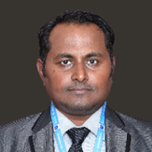
Mr. Sandhya Darshan Dash
Assistant Professor
sandhya@srustiacademy.ac.in
View Profile
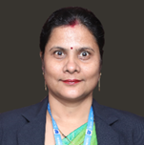
Ms. Saismita Das
Assistant Professor
saismita@srustiacademy.ac.in
View Profile
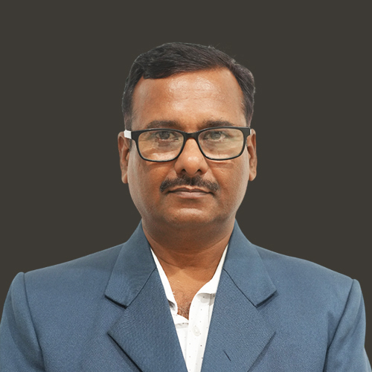
Mr. Nihar Ranjan Swain
Assistant Professor
nihar@srustiacademy.ac.in
View Profile
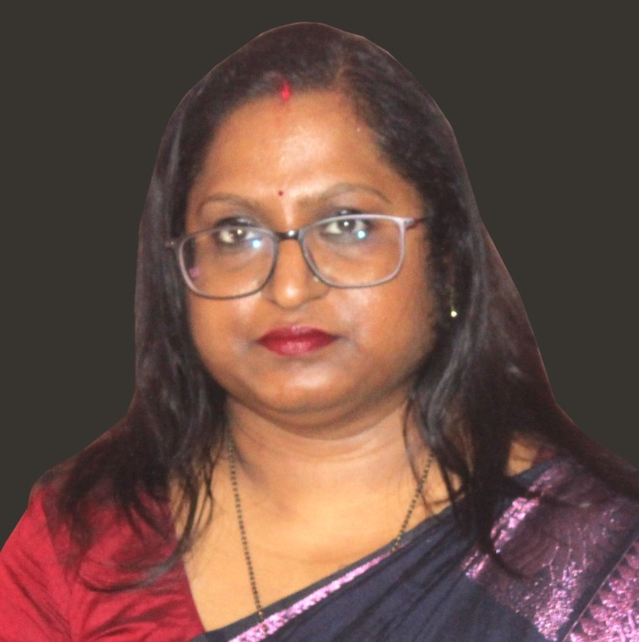
Ms. Rosy Barik
Assistant Professor
rosy@srustiacademy.ac.in
View Profile
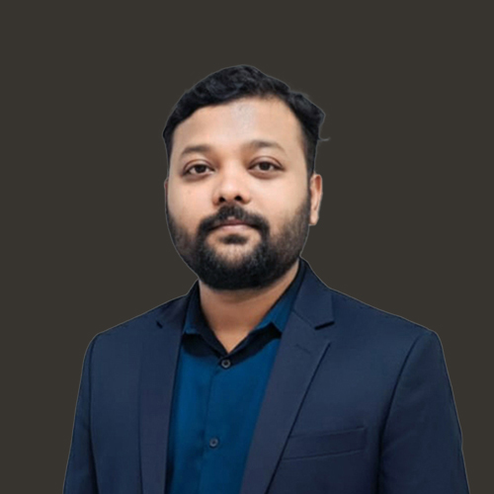
Mr. Alok Kumar
Assistant Professor
alokkumar@srustiacademy.ac.in
View Profile
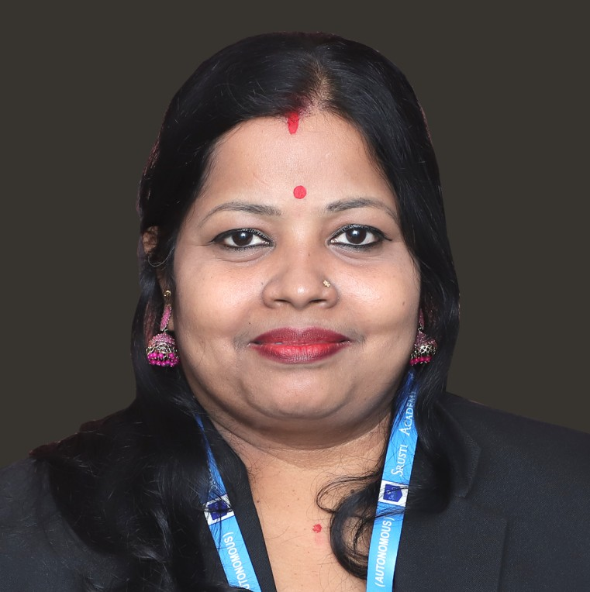
Dr. Bhabani Mallia
Associate Professor
drbhabani@srustiacademy.ac.in
View Profile
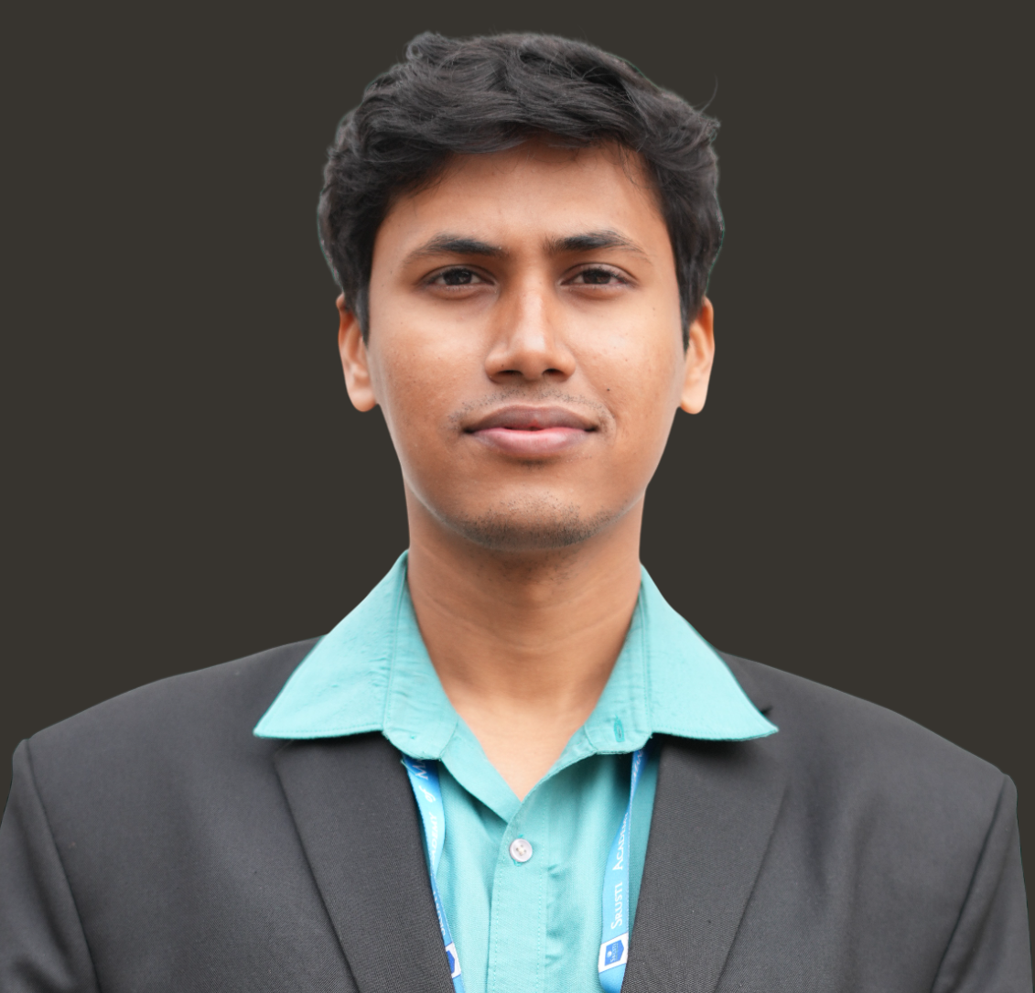
Mr. Amit Kumar Muduli
Assistant Professor
amit@srustiacademy.ac.in
View Profile

Ms. Diptimayee Mishra
Assistant Professor
diptimayee@srustiacademy.ac.in
View Profile

Mr. Sitikantha Biswal
Faculty & Research Associate
sitikantha@srustiacademy.ac.in
View Profile
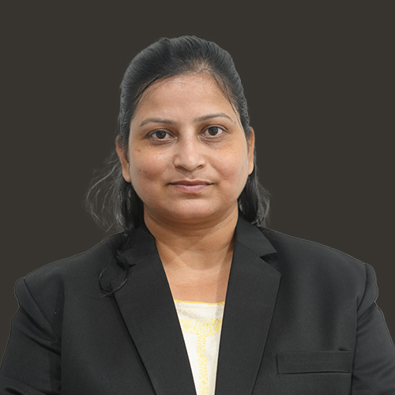
Ms. Chanchal Sharma
Assistant Professor
chanchal@srustiacademy.ac.in
View Profile

Mr. Sanchayan Mondal
Assistant Professor
sanchayan@srustiacademy.ac.in
View Profile
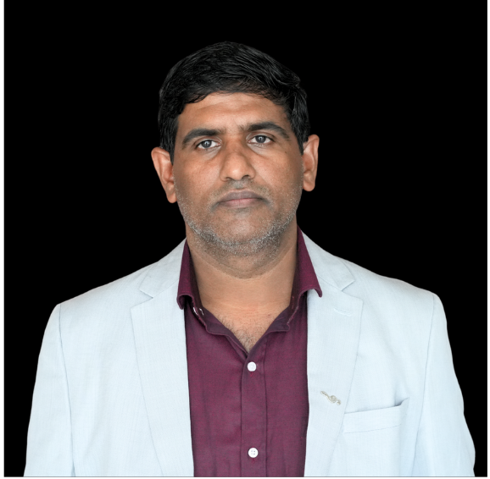
Mr. Debendra Kumar Rath
Assistant Professor
dev@srustiacademy.ac.in
View Profile

